Application of Flex-Z release agent with Pneumatic gun
Manual for spray gun
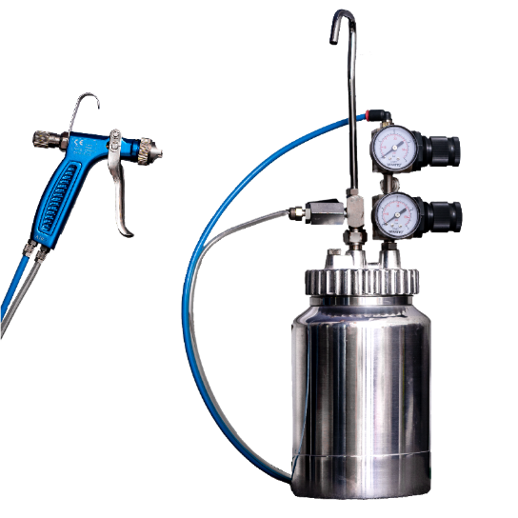
The application equipment is made up of a pressurized deposit and a specially designed pneumatic gun (see photo).
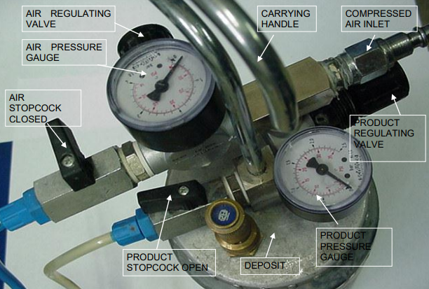
(this picture may vary in design from original product)

Before starting the application follow the instructions below:
Preparation:
A compressed air hose of ½ inch in diameter will be used to feed the equipment.
- Open the product and air stopcocks
- Open completely the product, pressure, and air regulating valves (regulating at maximum pressure)
- Disconnect the equipment from the compressed air inlet
- Depressurize the deposit pressing the trigger until it is depressurized
- Fill the deposit with a liter of FLEX-Z and close it
- Close the air stopcock and open the product one
- Connect the equipment to the compressed air inlet
- Press the trigger and bleed until only product free from bubbles flows through the transparent tube
Open the product and compressed air stopcocks following the equipment adjustment indications.
The measurement is 1:3 (e.g. 0,7 bar for product, and 2,1 bar compressed air) – see below:
Equipment adjustments:
Deposit  It comprises two regulating valves with a pressure gauge and a stop cock at the end of each one (see photos). The adjustment of the pressure regulating valves must be carried out while pressing the trigger and with the stopcocks open. | Product pressure  We must adjust the regulating valve. For this, the lever switch must be pulled towards the outside to free it and to be able to turn it, increasing or decreasing the pressure. The Product pressure gauge must be adjusted to 0,7 bar (the black scale allows reading the pressure value in Bar).
Air Pressure  We must adjust the regulating valve. For this, the lever switch must be pulled towards the outside to free it and be able to turn it, increasing or decreasing the pressure. The air pressure gauge must be adjusted to 2,1 bar (the black scale allows reading the pressure value in Bar). | Pneumatic gun  It has two entrances, one for the product (M) and one for compressed air (AIR). See the inscription on its handle to identify to which entrance each connection sleeve belongs to. - The Transparent sleeve carries the product from the deposit (M). - The blue sleeve supplies the compressed air to the gun (AIR).
Opening regulator  Its function is to open and close the air passage at the nozzle. Turn it to the close position, and marking it, count the total turns between the opening and closing positions. For the application adjust the regulator to half of its run. | Spray regulator  It is the one that allows adjusting the spray width of the Release Agent application. Open completely to reach the maximum width.
Nozzle adjustment
The flat side must be placed horizontally as the photo shows, for the spray to be vertically projected.

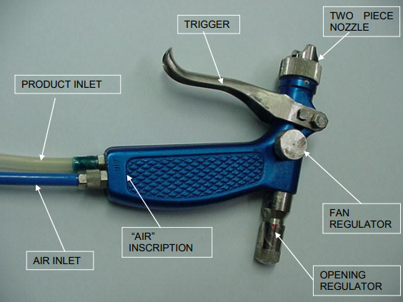

Application:
The mold must be at room temperature before applying the release agent. We will hold the deposit by the handle with one hand and the gun with the other, passing the tubes that communicate them behind us, for more comfort during the application.
THREE LAYERS must be applied, changing the direction of the application 90º between layers.
- Layer: Begin to spray transversally from the tip of the mold. Move forwards walking slowly the surface of the shell, covering its surface totally. The runs will be transversally carried out covering the maximum width possible until reaching the root.
We must always spray at a distance 30 to 50 cm.
Waiting time: if the application time is over ½ hour, from start to finish, the Flex-Z product must be considered cured and so we can start applying the second layer, beginning from the same point as in the previous layer. This way we avoid having to wait 30 minutes for the Flex-Z product to cure.
- Layer: Repeat the application as for the first layer, this time applying the Release Agent longitudinally until the whole surface is covered.
- Layer: Carry out in the same way as in the first layer, transversally.
ATTENTION: to conclude the Release Agent application with a gun, it is necessary to manually apply a very reduced amount of Release Agent on the molding surface edges, including the areas covered with adhesive Teflon.
sales@granudan.com | www.granudan.com | +45 4484 3756

Cleaning the equipment:
Just after the application has finished, it is essential to clean the equipment to avoid the product drying inside the gun and causing the obstruction of small internal components of the gun and valves. To do this, we must proceed in the following way:
- Open the product and air stopcocks. The pressure regulation and air valves must also be fully opened (adjust to maximum pressure).
- Disconnect the equipment from the compressed air inlet.
- Depressurize the deposit by pressing the trigger until it is depressurized.
- Open the deposit and empty the left-over product.
- Refill the deposit with ½ liter of water and close it.
- Close the air stopcock and open the product one.
- Connect the equipment to the compressed air inlet.
- Press the trigger and empty the water, using the gun, in a bucket until the product in the transparent tube is completely clean.
- Wipe the nozzle with a damp cloth and release it with your hand cleaning any remaining product inside. The nozzle can be manually dismantled in two pieces.
Once it is clean, repeat operations 2 and 3 to depressurize, and to empty the remaining water from the deposit.
Warnings:
During the application, the following warnings must be considered:
- Check that the nozzle is not blocked, always carry a damp cloth to rub the nozzle frequently to avoid any product accumulation. To avoid this, we must always press the trigger, avoiding releasing it for long periods of time during the application.
- This equipment avoids any leakages when pressing and releasing the trigger.
- Always clean the gun after each application, following the cleaning instructions.
- Care must be taken during the application to avoid the possible appearance of bubbles in the tube of the product. If this happens, we must bleed it again, spraying the product into the Release Agent drum, without the compressed air (close the air stopcock).
- During the application, the pressures shown in the pressure gauges must be periodically checked, readjusting the adequate values, if there is any variation.uently check the amount of used product, and refill if the level is too low.

